Problem Specification/Project Plan
Project Title: Practical Benchmarking of Approximate Machine Unlearning for Auditable Enterprise ML Erasure Workflows
Student Name: Niamh Hughes
Student ID: 40299386
Project Supervisor Name: Awais Rauf

- Introduction
  - Project Overview
This project implements and evaluates a reproducible benchmarking framework for approximate machine unlearning on tabular classification. Under the UK GDPR, deleting a raw record is insufficient if the trained model retains statistical influence from it. Full retraining guarantees influence removal but is costly; approximate methods are more efficient but their forgetting effectiveness and privacy properties are poorly understood for tabular settings. This project addresses that gap by comparing Full Retraining, Retain-Set Fine-Tuning, Gradient Ascent Unlearning and SISA across three tabular datasets, each under two GDPR-motivated deletion scenarios, producing a research artefact to support companies in discussing auditable erasure workflows with enterprise clients.
1.2 Objectives
To investigate existing machine unlearning techniques and their role in supporting data deletion requirements within machine learning systems.
To implement and evaluate Full Retraining, Retain-Set Fine-Tuning, Gradient Ascent Unlearning and SISA on tabular classification models.
To assess the impact of each unlearning method on predictive performance using AUROC and F1 Score.
To evaluate the similarity of unlearned models to a fully retrained baseline using prediction agreement.
To assess the effectiveness of each method in reducing privacy leakage through Membership Inference Attacks (MIA).
To compare the computational efficiency of machine unlearning methods against full model retraining.
To analyse the trade-offs between utility, privacy preservation and computational cost across multiple datasets.
To ground the experimental design in specific GDPR provisions (Article 17 and Article 5(1)(e)), translating the right to erasure and storage limitation principle into two distinct, reproducible forget-set construction methods.

- Problem Specification
2.1 Background and Context
The widespread adoption of machine learning across healthcare, finance and marketing has led to large volumes of personal data being used to train predictive models. The UK GDPR establishes strict obligations around data retention and deletion, and Article 17 grants individuals the Right of Erasure under several distinct legal grounds [19], two of which map directly onto the deletion scenarios simulated in this project. Article 17(1)(b) covers withdrawal of consent: an individual requests deletion regardless of how long their data has been held, corresponding to a consent-withdrawal forget set. Separately, Article 5(1)(e), the storage limitation principle, requires that personal data be kept "in a form which permits identification...for no longer than is necessary" [20], with no fixed time limit specified; the controller must instead define and document a purpose-appropriate retention period, after which records become eligible for deletion regardless of any individual request. This corresponds to a retention-expiry forget set, constructed via a simulated 'date captured' field (Section 3, Table 1). Critically, removing raw records under either scenario is insufficient if the trained model retains their statistical influence: a model that still permits re-identification of forgotten records arguably continues to violate Article 5(1)(e) even after deletion. Machine unlearning addresses this gap. Cao and Yang formalised the concept of making systems forget selected training data [1]; subsequent work introduced the SISA sharded-retraining framework [4] and gradient-based forgetting methods [3][5]. However, as Xu et al. [7] and the Deep Unlearn benchmark [8] highlight, evaluation remains inconsistent across methods, particularly for tabular settings relevant to enterprise governance. This project addresses that gap directly, evaluating each unlearning method under both deletion scenarios.
2.2 Problem Domain
The core challenge is that removing a record from a dataset does not remove its learned influence from model weights. Full retraining resolves this definitively but is prohibitively expensive for high-frequency deletion scenarios. Approximate methods reduce cost but introduce a verification problem: accuracy on the forget set alone is insufficient, as a model can achieve low accuracy through general performance degradation rather than genuine influence removal. Rigorous evaluation requires multiple signals: Membership Inference Attacks (MIA) [9][10] measure whether deleted records remain identifiable from model behaviour, and in this project are treated as a technical proxy for Article 5(1)(e) compliance, where an MIA score approaching random chance (AUC ≈ 0.5) indicates the model no longer "permits identification" of forgotten records. Prediction agreement with a retrained baseline captures convergence towards the model that would have existed without those records, and utility metrics (AUROC, F1) and runtime complete the picture. These four dimensions collectively address the benchmarking gaps identified in the literature [8], evaluated separately for both forget sets.

- Research Methods and AI Algorithms
An experimental approach will be adopted under controlled, reproducible conditions. Three tabular classification datasets were selected: Adult Income [14], Bank Marketing [16] and Hotel Booking Demand [17]. These vary in size, class balance and feature composition, testing whether findings generalise across tabular settings; all contain personal or behavioural data plausibly subject to erasure requests. A PyTorch MLP classifier is used as the base model as it is well suited to tabular classification and allows gradient manipulation, fine-tuning and sharding operations to be applied and interpreted without the confounds of more complex architectures, which is important for reproducible benchmarking. Two deletion scenarios are simulated for each dataset, reflecting the two legal grounds discussed in Section 2.1. The first, representing Article 17(1)(b), selects a random subset of individuals as a consent-withdrawal forget set. The second, representing Article 5(1)(e), adds a simulated 'date captured' field and defines a dataset-specific retention period (Table 1); records exceeding this period form a retention-expiry forget set. This allows each method to be evaluated against both a user-driven and policy-driven deletion scenario.
Dataset | Retention Period | Justification
Adult Income | 5–6 years | Employment/financial-history data; standard post-relationship review period.
Bank Marketing | 1–2 years | Direct-marketing contact data; time-bound purpose, periodic consent renewal.
Hotel Booking Demand | 1–2 years post-stay | Booking/guest data; short post-stay window for accounting/disputes.
Table 1: Simulated retention periods used to construct the retention-expiry forget set for each dataset (Article 5(1)(e)).
Four methods will be compared. Full Retraining trains a model from scratch on the retain set only and serves as the gold-standard baseline, providing the strongest influence removal guarantee at the highest cost. Retain-Set Fine-Tuning continues training the original model on the retain set; it is the most efficient approach but residual forget-set influence may persist. Gradient Ascent Unlearning maximises loss on the forget set to directly disrupt deleted records’ influence; expected to achieve stronger forgetting than fine-tuning, though retain-set utility may degrade if poorly constrained. SISA [4] partitions training data into shards and retrains only affected shards on deletion, the most principled approach architecturally, though efficiency gains may be modest at these dataset scales. Performance is assessed across four dimensions: utility (AUROC, F1), behavioural similarity to the retrained baseline (prediction agreement), privacy (MIA) and efficiency (runtime).
- Anticipated Results
The project will produce a comparative evaluation across all four methods, three datasets and both deletion scenarios. Retain-Set Fine-Tuning is expected to offer the fastest runtime but weakest forgetting, as nothing directly targets the forget set’s influence. Gradient Ascent Unlearning should reduce MIA signal more effectively, at the potential cost of utility degradation. SISA is expected to offer the most principled utility-forgetting trade-off by design, though runtime gains may be modest at these scales. Full Retraining establishes the upper bound for forgetting and behavioural similarity. The retention-expiry scenario may prove harder to forget cleanly, as records exceeding the retention period may share temporal patterns diffusely embedded across the model. The key outcome is characterising when each approach provides sufficient evidence of influence removal to be credible in an enterprise governance context.

- Project Plan and Timeline
See Appendix B

- Risk Management
Implementation Complexity of SISA
- Unlike the other methods, SISA requires data sharding, independent model training and prediction aggregation, introducing additional implementation complexity and development time.
- Mitigation: Full Retraining, Retain-Set Fine-Tuning and Gradient Ascent will be implemented and validated before SISA. The implementation will follow Bourtoule et al. [4] with shards kept deliberately small to limit complexity while maintaining core principles.
Verifying Whether Unlearning Has Actually Occurred
- Determining whether a model has genuinely forgotten deleted records is non-trivial. Strong predictive performance alone does not demonstrate unlearning, as models may continue to leak information about removed data despite similar accuracy.
- Mitigation: Multiple evaluation metrics will be used, including AUROC, F1 Score, Prediction Agreement with a Retrained Baseline and Membership Inference Attacks (MIA), providing a more comprehensive assessment of unlearning effectiveness.
Limited Observable Benefits of SISA
- SISA was designed for large-scale systems where full retraining is expensive. The datasets and model used here are comparatively lightweight, which may reduce the observable efficiency benefits reported in the literature.
- Mitigation: SISA will be evaluated across multiple datasets and compared against Full Retraining, Retain-Set Fine-Tuning and Gradient Ascent Unlearning using both performance and runtime metrics. Findings will be interpreted within the context of the selected datasets and model architecture.
Computational Resource Requirements
- Repeated training and unlearning experiments across multiple datasets and both deletion scenarios may exceed local hardware capabilities, particularly during extensive comparative evaluations.
- Mitigation: Access to Microsoft Azure through ISx4 allows GPU-accelerated VMs to be provisioned as needed (see Appendix A for full resource list). Experiments will run on local hardware first, with cloud resources used where additional capacity is required.

- References:
[1] Y. Cao and J. Yang, "Towards Making Systems Forget with Machine Unlearning," in 2015 IEEE Symposium on Security and Privacy (SP), San Jose, CA, USA, 2015, pp. 463–480.
[2] A. Ginart, M. Y. Guan, G. Valiant and J. Zou, "Making AI Forget You: Data Deletion in Machine Learning," in Advances in Neural Information Processing Systems (NeurIPS 2019), vol. 32, 2019, pp. 3513–3526.
[3] A. Golatkar, A. Achille and S. Soatto, "Eternal Sunshine of the Spotless Net: Selective Forgetting in Deep Networks," in Proceedings of the IEEE/CVF Conference on Computer Vision and Pattern Recognition (CVPR), 2020, pp. 9304–9312.
[4] L. Bourtoule, V. Chandrasekaran, C. A. Choquette-Choo, H. Jia, A. Travers, B. Zhang, D. Lie and N. Papernot, "Machine Unlearning," in 2021 IEEE Symposium on Security and Privacy (SP), 2021, pp. 141–159.
[5] S. Neel, A. Roth and S. Sharifi-Malvajerdi, "Descent-to-Delete: Gradient-Based Methods for Machine Unlearning," in Algorithmic Learning Theory (ALT), 2021.
[6] A. Golatkar, A. Achille, A. Ravichandran and S. Soatto, "Mixed-Privacy Forgetting in Deep Networks," arXiv preprint arXiv:2003.10933, 2021.
[7] J. Xu, Y. Wang, Y. Wang et al., "Machine Unlearning: A Survey," ACM Computing Surveys, 2024.
[8] X. F. Cadet, A. Borovykh, M. Malekzadeh, S. Ahmadi-Abhari and H. Haddadi, "Deep Unlearn: Benchmarking Machine Unlearning," arXiv preprint arXiv:2405.09355, 2024.
[9] R. Shokri, M. Stronati, C. Song and V. Shmatikov, "Membership Inference Attacks Against Machine Learning Models," in 2017 IEEE Symposium on Security and Privacy (SP), 2017, pp. 3–18.
[10] N. Carlini, S. Chien, M. Nasr, S. Song, A. Terzis and F. Tramèr, "Membership Inference Attacks From First Principles," in 2022 IEEE Symposium on Security and Privacy (SP), 2022, pp. 1897–1914.
[11] R. Eldan and M. Russinovich, "Who's Harry Potter? Approximate Unlearning in LLMs," arXiv preprint arXiv:2310.02238, 2023.
[12] P. Maini, M. Yaghini, N. Papernot et al., "TOFU: A Task of Fictitious Unlearning for LLMs," arXiv preprint, 2024.
[13] R. Kohavi, "Scaling Up the Accuracy of Naive-Bayes Classifiers: A Decision-Tree Hybrid," in Proceedings of the Second International Conference on Knowledge Discovery and Data Mining (KDD-96), 1996, pp. 202–207.
[14] B. Becker and R. Kohavi, Adult Data Set, UCI Machine Learning Repository, 1996.
[15] S. Moro, P. Cortez and P. Rita, "A Data-Driven Approach to Predict the Success of Bank Telemarketing," Decision Support Systems, vol. 62, pp. 22–31, 2014.
[16] S. Moro, R. Laureano and P. Cortez, Bank Marketing Data Set, UCI Machine Learning Repository, 2011.
[17] N. Antonio, A. de Almeida and L. Nunes, "Hotel Booking Demand Datasets," Data in Brief, vol. 22, pp. 41–49, 2019.
[18] N. Antonio, A. de Almeida and L. Nunes, Hotel Booking Demand Dataset, UCI Machine Learning Repository, 2019.
[19] UK Government, "Regulation (EU) 2016/679, Article 17: Right to Erasure ('Right to be Forgotten')," Legislation.gov.uk. [Online]. Available: https://www.legislation.gov.uk/eur/2016/679/article/17. [Accessed: 10-Jun-2026].
[20] Information Commissioner's Office (ICO), "Storage Limitation," ICO. [Online]. Available: https://ico.org.uk/for-organisations/uk-gdpr-guidance-and-resources/data-protection-principles/a-guide-to-the-data-protection-principles/storage-limitation/. [Accessed: 10-Jun-2026].

Appendix A: Hardware, Software and Data Resources
Hardware and Software Resources to be used within the project:
Hardware Resources
- Minimum 16GB RAM and multi-core CPU for data processing and model training.
- Access to Microsoft Azure through ISx4.
- Ability to provision Azure Virtual Machines (VMs) with GPU acceleration if additional computational resources are required.
- Access to university computing facilities as a secondary contingency option.
Software Resources
- PyTorch for implementation of the MLP model and machine unlearning techniques.
- Scikit-learn for preprocessing, model evaluation and performance metrics.
- Pandas and NumPy for data manipulation and analysis.
- Matplotlib and Seaborn for data visualisation.
- Visual Studio Code and Jupyter Notebooks for development and experimentation.
- Git and GitHub for version control and project management.
Data Resources
- Adult Income Dataset (UCI Machine Learning Repository).
- Bank Marketing Dataset (UCI Machine Learning Repository).
- Hotel Booking Demand Dataset (UCI Machine Learning Repository).
All datasets and software tools required for the project are publicly available or accessible through existing university and workplace resources.

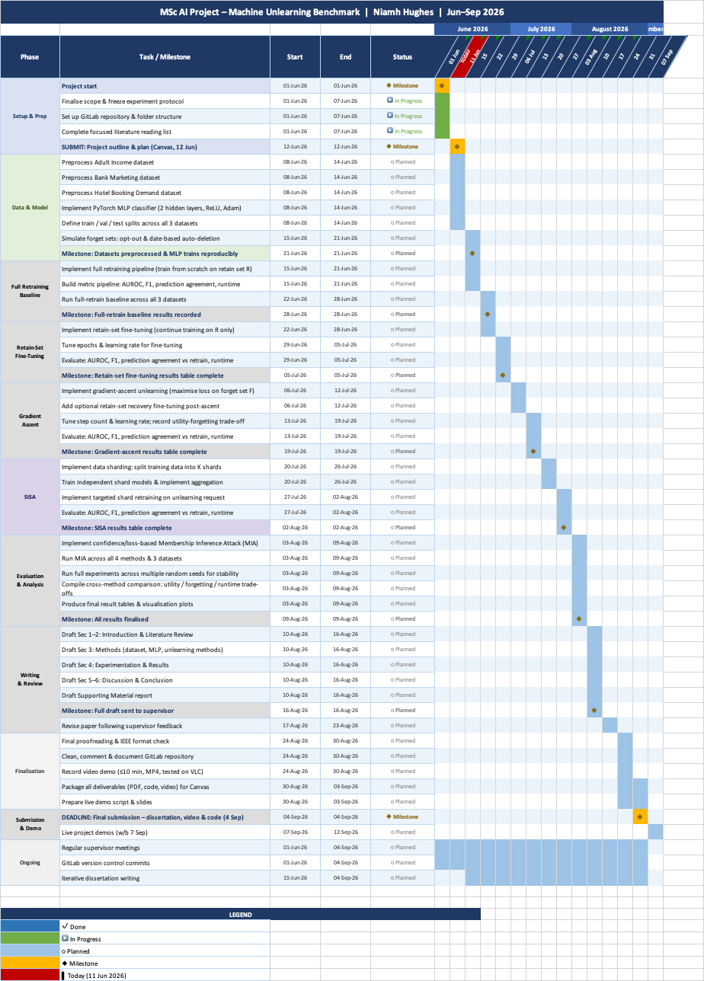
Appendix B: Gantt Chart

